

National College of Ireland
Project Submission Sheet

Student Name: | Mohd Nizam Mohd Nasir Shaikh
Student ID: | 24198170
Programme: | Master of Science in FinTech | MSCFTD1 | Year: 2025-2026
Module: | Financial Market
Lecturer: | Prof. Ciaran Hayden
Submission Due Date: | 10/January/2026
Word Count: | 6416

I hereby certify that the information contained in this (my submission) is information pertaining to research I conducted for this project. All information other than my own contribution will be fully referenced and listed in the relevant bibliography section at the rear of the project.
ALL internet material must be referenced in the references section. Students are encouraged to use the Harvard Referencing Standard supplied by the library. To use other author's written or electronic work is illegal (plagiarism) and may result in disciplinary action. Students may be required to undergo a viva (oral examination) if there is suspicion about the validity of their submitted work.

Signature: | Mohd Nizam
Date: | 09/01/2026

PLEASE READ THE FOLLOWING INSTRUCTIONS:

1. Please attach a completed copy of this sheet to each project (including multiple copies).
2. Projects should be submitted to your Programme Coordinator.
3. You must ensure that you retain a HARD COPY of ALL projects, both for your own reference and in case a project is lost or mislaid. It is not sufficient to keep a copy on computer. Please do not bind projects or place in covers unless specifically requested.
4. You must ensure that all projects are submitted to your Programme Coordinator on or before the required submission date. Late submissions will incur penalties.
5. All projects must be submitted and passed in order to successfully complete the year. Any project/assignment not submitted will be marked as a failure.

Office Use Only
Signature:
Date:
Penalty Applied (if applicable):

AI Acknowledgement Supplement:

Module: Financial Market (MSCFTD1)
Your Name/Student Number | Course | Date
Mohd Nizam Shaikh / 24198170 | Master of Science in FinTech | 09/01/2026

This section is a supplement to the main assignment, to be used if AI was used in any capacity in the creation of your assignment; if you have queries about how to do this, please contact your lecturer. For an example of how to fill these sections out, please click here.

AI Acknowledgment:
This section acknowledges the AI tools that were utilized in the process of completing this assignment.
Tool Name | Brief Description | Link to tool
N/A | N/A | N/A

Description of AI Usage:
This section provides a more detailed description of how the AI tools were used in the assignment. It includes information about the prompts given to the AI tool, the responses received, and how these responses were utilized or modified in the assignment. One table should be used for each tool used.

Evidence of AI Usage:
This section includes evidence of significant prompts and responses used or generated through the AI tool. It should provide a clear understanding of the extent to which the AI tool was used in the assignment. Evidence may be attached via screenshots or text.

Additional Evidence:
[N/A]
Academic Honesty Declaration
I declare the following to be true for this submission:
- I have completed the task during the designated time window and declare it to be exclusively my own work.
- I have not received, or attempted to receive assistance in preparing this response from any other person during the assessment window.
- I have not provided, or offered to provide, assistance to any other student by any means during the assessment window.
- I have read and understand the National College of Ireland guidelines of Plagiarism.
FINANCIAL MARKET TABA
Table of content
I. | THE RETURNS FOR 6-YEAR PERIOD FOR IBM, GENERAL MOTORS, S&P 500 & 3 MONTHS T-BILLS (RISK FREE RATE)
I.1. | THE EXPECTED RETURNS & STANDARD DEVIATION FOR IBM, GENERAL MOTORS AND S&P 500
I.2. | THE EXPECTED RETURNS, STANDARD DEVIATION AND DIVERSIFICATION EFFECT FOR PORTFOLIOS
I.3. | GRAPH OF FEASIBILITY SET CURVE OF PORTFOLIO ANALYSIS FOR IBM & GENERAL MOTORS
I.4. | THE BETA - CAPM FOR IBM & GENERAL MOTORS
II. | THE EVOLUTION AND FUNCTION OF DERIVATIVE MARKETS
II.1. | THE HISTORY, MOTIVATION & ROLE OF FUTURES MARKETS
II.2. | THE NATURE AND DISTINCTIONS BETWEEN FORWARD, FUTURE AND OPTIONS CONTRACTS
II.3. | THE ROLE OF EXCHANGES IN DERIVATIVE MARKETS
II.4. | THE USE OF MARGIN ACCOUNTS AND MARKING TO MARKET
II.5. | PRACTICAL EXAMPLE OF TRACKING THE MARKING OF A FUTURE CONTRACT TO MATURITY
II.6. | THE NATURE, ROLE AND OPERATION OF OPTIONS CONTRACTS
II.7. | APPROACHES TO VALUING FUTURES AND OPTIONS
II.8. | A CONTEMPORARY ANALYSIS OF THE CURRENT BEHAVIOUR OF FUTURES AND OPTIONS PRICES/MARKET FOR SELECTED ASSETS/COMMODITIES
II.9. | THE HISTORY, NATURE AND OPERATION OF CREDIT DEFAULT SWAPS
II.10. | THE ROLE OF CREDIT DEFAULT SWAPS IN THE FINANCIAL CRISIS OF 2007-2009
II.11. | RISK ASSOCIATED WITH DERIVATIVES AND THEIR CONTRIBUTIONS TO 2008 CRASH
II.12. | CONCLUSION
II.13. | REFERENCES

Project report
- THE RETURNS FOR 6-YEAR PERIOD FOR IBM, GENERAL MOTORS, S&P 500 & 3 MONTHS T-BILLS (RISK FREE RATE)
Excel URL (Excel uploaded separately too): https://docs.google.com/spreadsheets/d/1F5kx6im4mh-74eaeLTytD_Eo28p9gVxi/edit?usp=drive_link&ouid=111490828299032735772&rtpof=true&sd=true
The above table highlights the portfolio of IBM, General Motors, S&P 500 and 3 months T-Bills with the mean value of each of the investment for 6 years. To identify Covariance value of IBM & General Motors to get the actual Covariance, basically it is calculated for further identification of values.
1) the expected returns & standard deviation for IBM, General Motors and S&P500: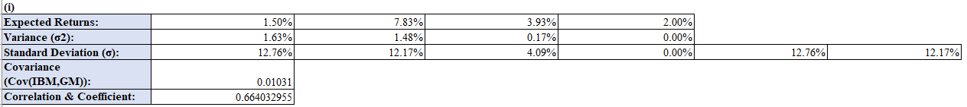IBM’s expected return was an average of 1.50% per year with standard deviation (risk) of 12.76% whereas General Motors expected return was 7.83% per year with lower risk of 12.17% as compared to IBM. On the other hand, S&P 500 expected return is 3.93% and risk was 4.09% defining as a safe investment. Therefore, Covariance results between IBM & General Motors was 0.01031 showcases movement of both the stocks and calculating Correlation Coefficient which is 0.664 illustrates they are completely independent and perfectly aligned for diversification effect.
2) The expected returns, standard deviation and diversification effect for portfolios:Through combination of investment in IBM & GM stocks in the portfolio, investors can reduce portfolio risk (SD) to less than either company alone showing the value of diversification. The volatility with the help of stock combination can be reduced by exploring the utilization of the set example with the mixture of investment by 40% into IBM and 60% into GM with the lower risk in portfolio for 11.35%, 50 – 50 percent on both stocks by minimum risk of 11.37% against investing alone in IBM with 12.76% & GM including 12.17% of risk. So, the diversification ratio for the safest investment were 1.09% by investing 50-50 percent on both the stocks is a risk return combination in portfolio for the investors who wanted to grow at steady pace.
3) graph of feasibility set curve of portfolio analysis for IBM & general motors:
It appears that the ideal portfolio allocation would be 50 – 50 percent investment of IBM & GM which results in a mean annual yield of 5.3% with the lowest portfolio risk of 11.37%. This illustrates the mix of risk and returns that provides the best risk-reward trade off among all the feasible portfolio combinations.
4) the Beta – Capm for IBM & General Motors:
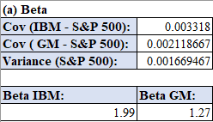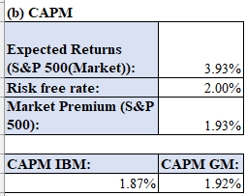
As per the Beta, IBM has a value of 1.99 which means it fluctuates up and down nearly twice as much as the stock market average as a whole when the market rises by 1% IBM often rises by 2%. GM has Beta value of 1.27% with movement around 27% compared to market as IBM and GM appears similar risky as the SD are early 12.76% & 12.17% which indicates a similar level of risk. Their Beta numbers, however reflects the reality as IBM adds a large amount of risk related to a diversified portfolio as compared to GM which is little bit less risky than IBM that showcases Beta is meaningful risk assessment for portfolio management than standard deviation.
According to CAPM, standard deviation measures total amount of risk which includes company specific risk that can be avoided with the help of diversification while beta measures non-diversifiable relevant market risk that investors actually face for compensation. The calculations make this clear and understandable that IBM and GM predicted returns were 1.87% and 1.92% based on the Beta of 1.99 and 1.27 for each of them which is not on their standard deviation rates. This shows that investors are only compensated for taking on systematic risk which is provided by Beta that directly provided information on sensitive stocks that are going to highlight changes in market. When the covariance of each stock is 0.003318 / 0.002119 is divided by variance 0.001669467 we got the beta yield which provides useful information about market sensitivity that cannot be obtained from standard deviation alone.

- TITLE: “The Evolution and Function of Derivative Markets”
Derivative market has grown into a central pillar of modern financial system across the globe which affected the commodity price, exchange & interest rates as well as terms of credit and derivative can be described as financial market product whose values depends on price plus performance of a core asset, index rate or events (Hull, 2018). The base is not only physical commodities like oil, wheat or gold, silver but financial commodities too such as equities, bonds, currencies & interest rates as there are more complex derivatives that involve credit events, inflation rates or weather patterns. These markets are mainly aimed to help individuals, businesses and organizations to manage risk by making predictions about future product prices although results in increased market efficiency through identifying price which leads to liquidity.
The main tool which is utilized in derivative market are forward, futures, options and swaps as contractual agreements involves the purchase or sale of an asset at fixed price in future are called as futures and forwards. Options are unique unpredicted payment scheme which grant rights but do not require trading asset at fixed price though swaps include transfer of cash flows and replacement of fixed interest payments by floating interest payments. Over the past centuries, the number and complexity of these tools have grown as of today the estimated value of global derivatives crosses hundreds of trillion dollars in addition it is being able to spread risk throughout the financial system it makes easier for businesses to maintain stable cashflow, reduce risk and allocation of capital more effectively. However, derivatives can come with significant risks as we have seen during the global financial crisis between 2007-2009 as it has a potential to increase financial instability when implemented in an irresponsible regulatory manner. Thus, an in-depth knowledge of development, operational procedures and legal frameworks within which derivative markets is essential to understanding the modern financial systems.
At earliest form of derivatives were simple agreements regarding future delivery and price as farmers and traders tried to fixed prices ahead of time using simple forward agreements in ancient and medieval marketplaces so that both the parties could better plan. There is no standard form and no central market in place for these early agreements which were simply private contracts between two parties and these leads to new issues as trade quantities were increased. A significant chance that one party would withdraw if the market price increased in their advantage because contracts were not standardized and there was absence of clear institution. Additionally, if circumstances changed there was no easy way to transfer or offset a position, as growing trade and high counterparty risk eventually led to a need for more structured, standardized risk sharing arrangements. Derivative market evolved over thousands of years, starting with straightforward agreements in ancient societies and in current time it progresses to extreme complex international market. Derivatives have its roots in early period to control unpredictability in agricultural production and trade despite of the fact that they are linked to modern finance.
1) The history, motivation & role of futures markets:
In the 17th century Japan organized 1st ever futures market at the Dojima Rice Exchange in Osaka were traders’ exchanges rice receipts from warehouse and futures for future delivery that developed rules concerning to contract quantity, delivery and default (Takatsuki, 2013). These Japanese markets sets an earliest example of how centralized trading and standardization may provide liquidity and price stability. Yet, in the United States particularly in Chicago modern future markets first appeared in the 19th century known as the Chicago Board of Trade (CBOT) which was founded in 1848 as a central market place for grain trades connecting Midwestern region farmers with eastern region buyers (Cronon, 1991). On the other hand, due to weather, transportation and fluctuating demand the cost of wheat, corn and other products was highly unpredictable.
At first CBOT members utilized forward contracts which were private agreements to provide grain at some certain prices on future dates but these forwards were customized and difficult to trade. In 1865 CBOT afterwards came with complete standardization and implementation of contracts with known quantities and qualified delivery sites, month by certain criteria initiated led to modern futures contracts. Standardization had several important effects firstly made contracts fungible meaning traders could easily offset positions as any contract of the certain types was the same as any other. Secondly, trading was placed in one particular place where prices were displayed publicly enables transparency in addition thirdly it made it simple to implement a clear system that could act as buffer between buyers and sellers which eliminates the risk of either party may fail to do so.
In the first half of 20th century, futures contracts were extended to other commodities such as livestock, metals and later energy items which results the need from producers and consumers to protect themselves from price risk. Motivation was still the same as customers and producers wanted assurance regarding the cost of their inputs while producers wanted security for the price they would sell. Futures offered a way to shift price risk from people who wanted to get away from it to future traders who were willing to bear it on the hope of making profit with this approach it stabilizes the supply chains which lead to improved real economy of firm’s ability to plan investment, employment and production.
The 1970s were an important turn point in the development of derivative market as the collapse of Bretton woods system results in the replacement of fixed exchange rates and currency values. Exchanges responded by providing options and futures based on financial securities starting with currency futures and moving on to interest rate and stock index futures. In 1972, the Chicago Mercantile Exchange (CME) came up with currency futures followed by Eurodollar and Treasury futures that aims to help banks and corporations to manage with their foreign exchange and interest rate risks. In 1973, the Chicago Board Options Exchange (CBOE) was launched for standardised stock options and they came with Black Scholes Merton options pricing model which is a strict method of valuing contracts. Due to these improvements, derivatives are playing a vital role as a tool for managing financial risk rather than only a tool used for commodity market (Kolb and Overdahl, 2010).
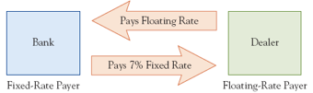
Derivative tool was further expanded in 1980s & 1990s over the interest rate swaps plus currency swaps, permitted to banks and corporations to trade in payment types as a result of changing their nature of commitments, in terms of asset allocation and trading were very popular at equity index futures and options (Kolb and Overdahl, 2010). The 1990 saw the development of credit derivatives and credit default swaps (CDS) as a way to transfer credit risk from bonds and loans also complex structured products as well as advanced pricing and risk management models were emerged due to dynamic development of computing & telecommunication systems. The notional value of outstanding exchange traded and over the counter derivatives has surpassed the world GDP on several period.
The role of futures in this broad derivatives environment explains main 3 functions as trading, price discovery and market efficiency. As trading role in futures market for user is to secure either purchase or sale price of an asset in coming months or years. For example, a wheat farmer who can sell a future for securing a price of their harvest, an airline can buy jet fuel futures for stabilizing fuel prices or pension funds which can buy equity index futures such as those based on S&P 500 or FTSE 100 for stabilizing portfolio value this are three key examples of using futures contract to secure fixed price for a later date. Future market for price discovery role can be summarize as mixed information on predicted future demand and supply from large number of buyer and sellers. Since one can see future prices of multiple maturities of the prices which reflects the market expectation that has future spot prices although it is not helpful only for traders but for producer and policymakers too. Lastly, future market improves liquidity because large holdings placed or sold quickly with minimum transaction costs it is possible by use of central clearing standardization allowing risk to transferred from those who does not bear for exposure to those who willing to take on.
Furthermore, the rise of derivatives has also drawn attention according to some observer’s investment in these markets could might commoditize future trading for such commodities like food and oil as may occasionally increase price volatility. Complex derivatives had ability to hide real risk positions, encourage excessive borrowing which makes crisis management more complicated. The financial crisis of 2007-2009 illustrates an unforgettable example of how some of the derivatives especially credit default swaps can be misused and cause system instability. However, the majority of scholars and policy researcher demonstrates that derivatives are well structured, margined and transparently traded by reliable infrastructure which offer substantial benefits in the form of developing more effective redistribution of risks throughout the financial system.
2) The nature and distinctions between forward, future and options contracts:
First starting with forward contract is a mutual contractual agreement between two parties for purchase or selling an asset at certain prices at future period which is typically made over an open market rather than exchanges. Both the parties can choose a unique maturity time based on their choice of quantity and delivery conditions that needs to meet their requirements due to personalized forwards. It is basically useful for those company who wants to set the price for non-standard asset like any specific metals for example copper that will need to delivered to a factory on non-standard date. Despite this there isn’t a central clearinghouse that will ensure performance which leads to counterparties risk. Profits & losses construct until maturity but if the market price suddenly fluctuates one of the parties will have huge unsecured exposure to other.
Secondly, future contracts are developed in modern era to solve majority issues although future contracts are a standardized and traded contracts on well-organized exchange, it is economically compared to forward contracts in that way which serves to fix future prices. The size of contracts, the number of months that delivery could be completed, the suitable quality of assets and at last the settlement procedures are all set & handled by exchanges. All transaction cleared through central counterparty that acts as a mediator between consumer & producer. This setup minimized personal counterparty risk that ensures there will motivations to parties to trade with identical contract which enhances liquidity and lowered spread between bids and asks.
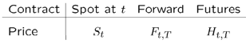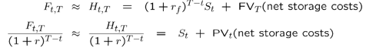
Thirdly, based on facts that option contracts are right rather than commitment that sets them apart from forward & future contracts while put option gives buyer right to sell at strike price on or before expiration date. Consumer purchased this right at premium if option turns out of the money than they will just let it expire results in losing the premium. By contrast, option writer receives premium but they are liable to significant losses if the buyer chooses to exercise. It is the discrepancy that options are especially useful for trading as the investors can sell the covered calls to earn income or profits as well as buy put options to protect their portfolio that exposes to downside risk but has no upper boundary.
To sum up, options are unpredictable profits based on rights rather than debts which makes them powerful tools for risk profile management, futures are standardized traded and centrally cleared with fewer exposure but highly restrictive and consistent. Lastly, forwards are customized, mutual understandable and flexible for conditions but with increased exposure to credit risks.
3) The role of exchanges in derivative markets:
Derivatives exchanges plays a crucial role in running and functioning derivative markets before the development of modernized era transactions took place via private agreements with limited liquidity. Since organized exchanges such as CME group, Eurex and ICE takes place into the modern market which act as central marketplace for listing plus trading standardized futures and options as exchanges negotiates the terms of contracts, run and operates on electronic trading platforms which enforces transparent rules and regulations. It is all about how the order would be handled in addition market etiquettes, surveillance and rules & regulations followed while offering real time price and quantity information. Focusing on large number of buyers and sellers the exchanges aim to help in price discovery and liquidity although interestingly this switch to a screen-based trading system that made it easier for traders from all over the world to take participation in the market that leads to decreased in transaction costs.
Overall exchanges give better infrastructure place to traders or investors and brokers to work in derivative market transparent, efficiently and securely without the exchanges it would be difficult to function and derivative would remain risky which is not accessible by all rather than only by big management companies. However, it has also made clear and easier for highly frequent trading schemes resulting in intraday volatility. Therefore, there is pros & cons of trading in derivative market but with the development of exchanges it was easier day-by-day to an individual to under the circumstances and trade so it been essential to growth and stability for global derivative markets.
4) The use of margin accounts and “marking to market”:
The exchange’s counterparty risk is balanced by clearing house or central counterparty (CCP) as when two of the traders in exchange agreed for transaction CCP steps in and becomes buyer’s legal seller and for seller’s legal buyer. In the event, when open positions were taken CCP wants that their members to deposit initial margin for covering potential losses in unusual business environment as well in variable margin that showcase daily profits and loss in market. CCP utilises a mutualized default funds to protect against losses for unknown circumstances and margin of a clearing member in the event of default as there have been few CCP failures till now in the modernized markets because of the strong structure (Duffie and Zhue, 2011).
The margin accounts and daily marking to market are most important elements for risk control because instead of paying the notional amount of contract at the period of its starting traders will announce a relatively small amount of initial margin which is typically 5% to 15% of the notional that is acts as security performance (Hull, 2018). Although at the end of trading day exchanges will decide and sets the settlement price for each of the contracts where every open position is revalued at the current price. Trader’s account is credited or debited via marking to market for the variation margin which is daily profits or losses of their investment. In the instance of losses which is causing the account balance to drop by below daily margin requirement so the clearing member steps-in and close the position to prevent future losses and the trader shall may exposed to a margin call to add more funds.
5) practical example of tracking the marking of a future contract to maturity:
A straightforward numerical example explains the processes, an investor who has a single legal contract for a futures contract that will involves trading of 1000 barrels of crude oil at the price of $70 per barrel. As the investor initial margin is $5000 in addition their maintenance margin is priced at $3750 at every day of trading the prices will shifts by $68 to $72 per barrels which leads to gain or loss of $68 or $72 per barrel. In the investment to futures contract profits are earned and production is achieved through price fluctuation compared to the previous fixed prices agreements. However, when the price drops suddenly on some days margin account may also fall below the maintenance level that will lead in a margin call which will require that the investors to make extra deposits immediately in order to restore balances. On the other hand, when prices rise thus account balance will also increase, for example, the ultimate results of a $1250 profit and the margin final balance of $6250 after 10 days. Despite of this there are multiple examples where account balance is at or below the maintenance and in future it would require to coverup. Large and transparent losses cannot build up and the CCP is able to guarantee that the prevention of default risk in futures market through daily settlement and disciplined marketing.
6) The nature, role and operation of options contracts:
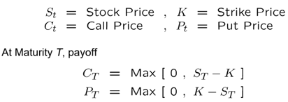
Options contracts are effective as they allow investors to modify their risk-return profiles through buying rights instead of restrictions as a buyer who makes purchase of call option, they will pay the premium which enables them with the right to buy underlying asset at strike price. As a result, in the period of expiry if market price will be higher than the strike price so call option will be performed as profit and if it will be lower than the strike price than buyer would only receive the premium. By contrast, put options operates by offering insurance against deficient prices although options preferred for hedge investment trading over volatility and as it will defined as money-making because of the minor drawbacks and possibly greater benefits. As an illustration, a portfolio manager might buy put options on a stock index for safeguarding their portfolio against any unknown instance like market crash or sudden fluctuation in any of the investment that results in a protective put strategy or sell called options on stocks as manager already owns to produce additional incomes.
There are variety of exercises in option style as in America it can be done at any point of time before the option expires where in Europe it can only be done at the period of maturity. This difference affects the options value as well as the strategic usage for instance, American options are more valuable due to their high level of flexibility particularly when it comes to assets that pays dividend or when exercising them early can be ideally beneficial.
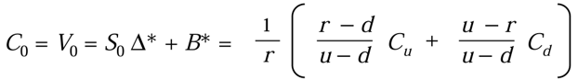
Due to the fact that intrinsic value and time value are two elements composed the price of an option or premium but the amount of option that is currently in money is determined by its intrinsic value which is the difference between strike and spot for a put between spot and strike for a call option. The premium on intrinsic value that is to be considered the possibility that the options value will increase by the time of expiration is called as time value. Though when the underlying asset is more volatile and the terms of expiration is huge than time value increases and decreases based on the approach of expiry that is a process known as time decay or theta.
7) Approaches to valuing futures and options:
In the futures context, the cost of carry model is the fundamental model of valuation as it states the fair price of the futures at any point of time that must be equal to the spot price plus the expenses and benefits of holding the underlying asset until the delivery date (Hull, 2018), (Brennan, 1958). The earnings of the underlying asset featuring dividends or convenience yield and on the other hand the costs of financing, expensive storage and insurance. Formula for the relationship in form of continuous compounding is usually described as future price=spot price which is need to multiplied by the exponent of net carry rate times to maturity. Arbitrageurs may buy or sell the underlying asset and counterbalances futures contracts that makes relative profits which is risk-free when the real future price is far lower or higher than the theoretical price which is likely to push prices back towards stability.
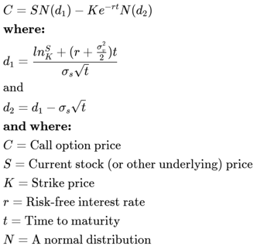
Alternatively, under the assumption of constant volatility, interest rates and frictionless markets at the Black-Scholes-Merton model which was created by Fischer Black, Myron Scholes and Robert Merton in 1973 as the model follows a geometric Brownian motion with constant volatility (Black and Scholes, 1973). It provides a closed form expression value of European call and put options on non-dividend paying stocks. The model is basically based on non-arbitrage concept by creating a dynamic hedge between the option and underlying commodities, it defines as the call price is based on the current spot price, strike price, expiration time, risk-free rate and volatility (Merton, 1973). Nowadays the Black-Scholes model is still broadly used despite of its simplified assumptions as it is frequently altered to account for dividends and other types of volatility. The Greeks delta, gamma, theta, vega and rho measures the option prices sensitivity to changes in different parameters as these risk metrics are essential for creation of hedging strategy and options portfolio management. Predicted volatility also referred as inverse formula which is simultaneously inverted by traders and is used to calculate the amount of volatility which reflects the consistent volatility level with current option prices. This represents what happened to market in deciding how unpredictable prices will be in future.
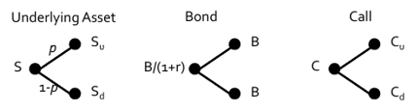
American options or more complicated payoffs are involved than binomial model is preferred as it builds a specific tree of potential future prices where the underlying can either rise or fall depending on conditions at every point. Subsequently, it uses risk-neutral probability to value the option by moving backwards through the tree allowing the option to perform early when beneficial. The binomial model retains the flexibility to do early training and testing, separate dividends and path dependencies while shrinking to Black-Scholes option prices as the number of steps increases in addition a key consistency feature between European call and puts of the same strike and maturity is called as put-call parity. Although, to prevent arbitrage deals a portfolio made up of call and discounted bonds of the same value but as the strike must have to same value as portfolio made up of an underlying commodity and call with this relation it helps traders to spot mis-pricing and establish a digital position tool to mimic other.
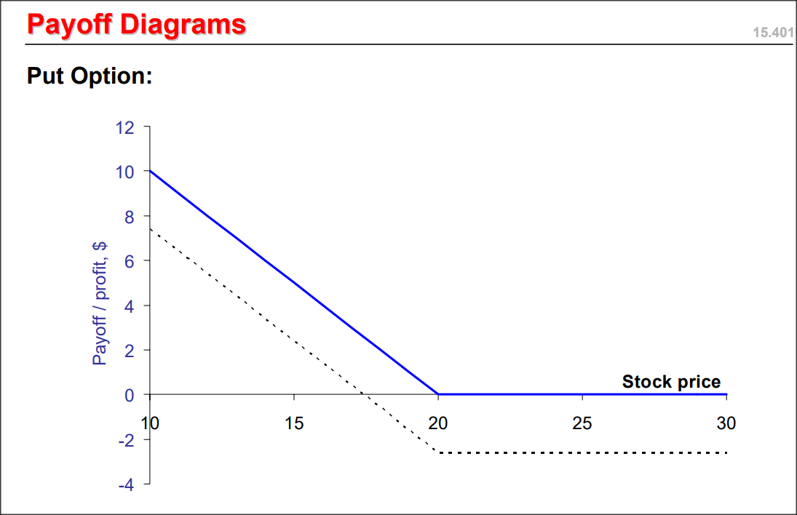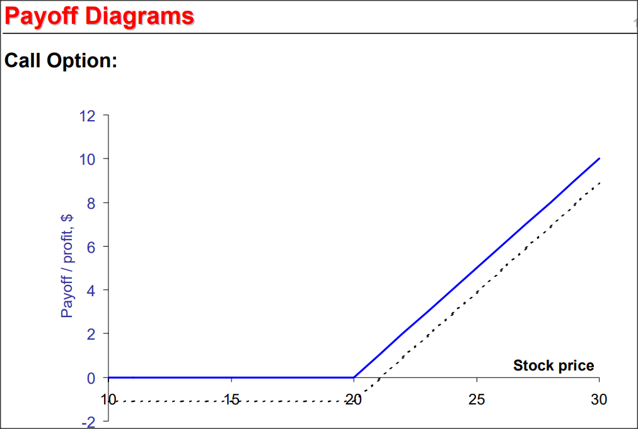
8) A contemporary analysis of the current behaviour of futures and options prices/market for selected assets/commodities:
Over the past years, futures and options market have expanded and evolved by new economic realities and technological advancement, at least 11 billion of contracts were exchanged in the United States all alone in 2024 that is at peak. Options market evolved significantly as the Volatility Index (VIX) described as “fear index” which measures expected volatility in equity market of U.S which is derived from S&P 500 options prices (Whaley, 2000). During the period of market stress such as 2008 financial crisis or COVID-19 pandemic, VIX basically surges which reflects high level of uncertainty. This huge trading sets new record for the volume of equity options trading in particular very short dated versions of zero day to expiry (0DTE) options of stock indexes and exchange traders funds that has witnessed particularly rapid growth (Alexander and Korovilas, 2023). Targeting hedging flows near expiry and possibly increasing intraday volatility as these agreements allow traders to take low-cost intraday positions at index fluctuations. It is evidence that in market it studies around major events such as elections and central bank decisions which showcase surges in 0DTE volume and predicted volatility which are the signs of growing uncertainty and short-term forecasting.
Commodity future markets showcase different trends in recent years depending on underlying asset due to inventory levels and expected demand-supply ratio as well as geopolitical tension which changes in global demand as OPEC decisions to decrease or increase supply had an effect on future prices. On certain scenarios, such as COVID-19 pandemic illustrated difficulties in oil demand which is a historic moment in April 2020 when West Texas Intermediate (WTI) crude oil futures traded at negativity prices. These decisions have caused crude oil future prices in 2024-2025 to move with future curves to move in downward or backward futures direction. As gold futures have not been poor and it remains strong because it is the reliable secured investment for investors, although during the period of macroeconomic instability and evolving preferences towards the interest-rate expectations. Agricultural futures prices for grains and soft commodities are affected by weather fluctuations, supply chain problems, climatical incidents such as El Nino, trading difficulties and changes in consumption affects productions and distribution as research demonstrates that there were lead-lag and volatility relationship between spot and future markets.
On a structural level, post-trade and clearance procedures are still in evolving period but the industries projection for 2024-2025 focus on the expansion of central clearing, improved protection of asset, trend of cloud computing usage, data analytics and machine learning for pricing and risk management systems. In order to balance the reduction of risks against the market operations, regulatory practices have enhanced restrictions on margin, reporting and platform trading. Such examples of these regulations include the regular testing of pro-cyclicality of margin models and stability of central counterparties.
9) The history, nature and operation of Credit Default Swaps:
Firstly, defining the Credit Default Swaps (CDS) which are derivatives that allow one party to transfer the risk of a defaulting borrower to another party. The seller promises to compensate buyer in the incidents of payment default, insolvency or restructuring in that term’s buyer pays a frequent fixed premium called as the CDS spread. In other circumstances such as cash settlement, the seller receives the variation between the bond’s face value and its post default price. In physical settlement, the buyer of default bond delivers the bond to seller who pays the face value. The spread, in basis points out the notional amount, the markets perception of reference entity’s default risk and expected recovery led to CDS prices that becomes a key indicator of evolving credit conditions. In 1990s, when CDS was introduced to real world it allows JP Morgan and other major banks to transfer the risk of loans off their balance sheets and reduce capital requirements while still upholding client relationships. It was quickly spread to single name corporate CDS then index CDS on company baskets, sovereign CDS on countries and CDS on structured assets including Mortgage-Backed Securities (MBS) and CDO tranches pushing outstanding notional which had reached 10s of trillions of dollars by 2007 (Duffie, 1999).
CDS market based on legal and operation regulations that has established by International Swaps and Derivatives Association (ISDA) introduced standardization of credit events, settlement and auctions techniques to fix the recovery prices in the situation of default. Nearly all CDS were trader over the counter banks to hedge funds and insurers before the financial crisis where no central clearing was done with little reporting and high counterparty risk. Banks implemented CDS to hedge loan and bond portfolios, investors used them to speculate the changes in credit quality an arbitrageurs trade the difference between bond yield and CDS spread. Since CDS premiums required substantially less amount of capital at the initial period of investment than those needed to buying or selling bonds often used leverage in their trading. Due to the combinations of large volumes, leveraged books and non-transparent foreign exposures CDS had become deeply integrated in the global credit system by the mid of 2000s, even though many market players and regulators were unaware of how dependent and unstable the network of CDS obligations had become grown.
10) The role of Credit Default Swaps in the financial crisis of 2007-2009:
Credit default swaps played a crucial role in 2007-2009 financial crisis, as a tool for transferring credit risk and source for instable system at that moment CDS market grew up rapidly reaching to the value above $60 trillion by 2007 (Stulz, 2010). In addition to traditional corporate and government bond holdings, CDS were mainly written on MBS and CDO tranches on subprime ahead to the 2007-2009 crisis. While some dealer and hedge funds used CDS to cut off subprime risk by buying protection on tranches they usually did not own although many bank, insurers and financial institutions bought high-rated CDO tranches with CDS protection believing that such combination will be risk free. This usage of CDS helped on the expansion of subprime securitization and created a false sense of security for complicated assets whose risk models had underestimated the potential to become correlated due to the high rate of mortgage defaults. Owing to AIG’s Financial products division selling large amounts of CDS protection on so-called super senior CDO tranches, collecting premiums and initially offering little collateral on debt though CDS spreads increased and credit rating were decreased as US house prices declined (Stulz, 2010). This leads to huge number of collateral calls that AIG went bankrupt on which forced the government to bail out the AIG CDS holder counterparties papers that was worth over $180 billion.
Further weakness was exposed by the September 2008 that was failure of Lehman Brothers despite an effective successful process of auctioning 1st via ISDA, which showed net payments were significantly lower due to large number of positions eliminated. The event illustrated how small regulator knows about who is exposed by what amounts, thus the gross notional written on Lehman was massive. Banks were afraid to lend to one another because of the mysterious network of obligations among CDS which were traded directly without central clearing or complete proper reporting which led to believed that counterparties would suffer badly as a result of CDS losses (Longstaff, 2010). With the aim to reduce counterparty risk and improve transparency during the post-crisis period, it is mandatory for central clearing of standard CDS, reporting trading to repositories, greater capital and margin requirement under the Dodd-Frank Act in US and EMIR in Europe were implemented. However, there were still concerns about concentration of risk among those small number of clearinghouses and pro-cyclical margin calls in future stressful situations.
11) Risk associated with Derivatives and their contributions to 2008 crash:
Derivatives especially multi-layered over the counter derivatives like credit default swaps represents some of the primary risks that led to global financial crisis of 2008 as result of decrease in housing. The allowed banks, insurers and hedge funds to hold large positions in terms of little amount of upfront capital, hence when the market flipped the loss and collateral calls were so huge in terms of available funds. Hedge holdings in CDO tranches was risky than they seemed since many structured commodities that were secure on paper were based on hopeful assumptions that underestimated how strongly mortgage defaults may set in to move together. When the period of crisis, AIG and Lehman encountered many difficulties, the fear of undetectable losses on derivatives spread so widely that it was effectively closed the lending source and created panic throughout the system. Due to the majority of CDS and several other derivatives were private which means that no one could see who was left, what was they suffered from a trade. In short, rather than absorbing shock, leverage, poor models and hidden foreign derivative links increased it (Acharya et al., 2009).
12) Conclusion:
Overall, the evolution of derivatives from simple forwards to modernized futures, options, swaps and Credit default swaps helped companies and investors to properly analyse and bear risks, arrange cash flows and find prices in all the possible way such for commodities and interest rates. Derivatives are organised exchange, margining and clearing houses showcases those derivatives can aid to solve market stability by distributing risks in open ordered manner. In the meanwhile, the 2007-2009 crisis showed that in the event of inadequate laws and risk management the risk of complicated highly leveraged and unclear derivatives can cover up problems encouraging people to take excessive risks and quickly spread stress throughout the financial system. Derivatives benefit roles in system should preserved improvements of central clearing, trade reporting and huge capital and margin requirements after the following crisis. However, these changes will only be successful if companies and regulatory authorities maintain discipline on new products and trading schemes arise.
13) References:
1. Hull, J.C., 2018 Options, Futures and Other Derivatives. 10th ed. Harlow: Pearson.
2. Takatsuki, Y., 2013. The Dojima Rice Market and the Origins of Futures Trading.
3. Cronon, W., 1991. Nature’s Metropolis: Chicago and the Great West. New York: W.W. Norton.
4. Kolb, R.W. and Overdahl, J.A., 2010. Financial Derivatives: Pricing and Risk Management. Hoboken: Wiley.
5. Duffie, D. and Zhu, H., 2011. Does a Central Clearing Counterparty Reduce Counterparty Risk? Review of Asset Pricing Studies, 1(1), pp.74-95.
6. Brennan, M.J., 1958. The Supply of Storage. American Economic Review, 48(1), pp.50-72.
7. Black, F. and Scholes, M., 1973. The Pricing of Options and Corporate Liabilities. Journal of Political Economy, 81(3), pp.637-654.
8. Merton, R.C., 1973. Theory of Rational Option Pricing. Bell Journal of Economics and Management Science, 4(1), pp.141-183.
9. Whaley, R.E., 2000. The Investor Fear Gauge. Journal of Portfolio Management, 26(3), pp.12-17.
10. Alexander, C. and Korovilas, D., 2023. Short-Term Options and Market Quality: Evidence from Zero-Days-to-Expiry Options.
11. Duffie, D., 1999. Credit Swap Valuation. Financial Analysts Journal, 55(1), pp.73-87.
12. Stulz, R.M., 2010. Credit Default Swaps and the Credit Crisis. Journal of Economic Perspectives, 24(1), pp.73-92.
13. Longstaff, F.A., 2010. The Subprime Credit Crisis and Contagion in Financial Markets. Journal of Financial Economics, 97(3), pp.436-450.
14. Acharya, V.V., Philippon, T., Richardson, M. and Roubini, N., 2009. The Financial Crisis of 2007-2009: Causes and Remedies. Financial Markets, Institutions & Instruments, 18(2), pp.89-137.

